|  |  |
| --- | --- |
| Please fill in the name of the event you are preparing this manuscript for. | SPE Asia Pacific Oil & Gas Conference and Exhibition 2022 |
| Please fill in your 6-digit SPE manuscript number. | SPE-201xxx-MS |
| Please fill in your manuscript title. | Tuffs and Volcaniclastics: A Potentially Underexplored and Underdeveloped Reservoir Type |
| Please fill in your author name(s) and company affiliation.   |  |  |  |  | | --- | --- | --- | --- | | Given Name | Middle Name | Surname | Company | | Munish |  | Kumar |  | | Kanna |  | Swaminathan |  | | Michael |  | Braim |  | | Maria Irene Inggrid |  |  |  | |  |  |  |  | |  |  |  |  | |  |  |  |  | | |
| This template is provided to give authors a basic shell for preparing your manuscript for submittal to an SPE meeting or event. Styles have been included (Head1, Head2, Para, FigCaption, etc.) to give you an idea of how your finalized paper will look before it is published by SPE. All manuscripts submitted to SPE will be extracted from this template and tagged into an XML format; SPE’s standardized styles and fonts will be used when laying out the final manuscript. Links will be added to your manuscript for references, tables, and equations. Figures and tables should be placed directly after the first paragraph they are mentioned in. The technical content of your paper WILL NOT be changed. Please start your manuscript below. | |

Abstract

Tuffaceous reservoirs are known to contain hydrocarbons which can sometimes be of significant volumes, examples being in China and South America. However, such reservoirs are relatively underexplored and underproduced, fundamentally because they are challenging to understand. Typically, if tuff facies are encountered in conventional reservoirs, they are ignored. Yet, a proper understanding of how such reservoirs behave may prove appealing to explorers looking for the next big “whale” in exploration.

The flow mechanism in such reservoirs is governed by numerous variables; the very nature of the tuffaceous facies means that pore structure, pore type/ size, mineralogy, and rock-fluid interactions impact reserves estimation, recovery factor and sweep efficiency at the reservoir scale. Pore scale distribution of fluids within the rock will, in turn, determine petrophysical and geophysical response of the reservoir rock. Conventional logging methods may not necessarily work well in tuffs as they contain trace amounts of radioactive minerals, and grains sometimes contain surface roughness at the nanoscopic scale that impacts how fluids are distributed.

The main challenge with the interpretation of tuff facies is the lack of a universally-accepted interpretation methodology, because of variability in the logs and fields. In this paper, we will discuss how we conducted an analysis of a tuffaceous reservoir located onshore Cuba, South America, which has been in production for over 30 years. Through an integrated approach based on first principles that considers aspects of the geology, geophysics, petrophysical and reservoir engineering, and by combining deterministic, statistical, and probabilistic methods, we will prove that one can sufficiently de-risk properties, which would allow methods defined by the SPE Petroleum Resource Management System (SPE PRMS) to evaluate resource size and remaining reserves potential.

Our method is based on first principles because we consider the reservoir holistically, across scales that span nine orders of magnitude. We started our analysis by firstly looking at thin sections and cores to cement our understanding of the facies, particularly the pore morphology (nm scale), before moving on to the macro properties, such as porosity-permeability and trapped residual saturation (m to cm scale). As logging tools are not designed to measure tuff properties accurately, we next applied a statistical approach and calibrated our log measurements to core on a field-wide basis (cm to m scale). We combined our calibrated properties with the structure and stratigraphy at the geological scale (m to km). To close the loop, we tied our results to the production profile and estimated recovery factor, which was cross-checked against reservoir engineering principles. Through this integrated approach of understanding the field at multiple scales, we could deterministically define the boundary for static properties, statistical results from the DCA and finally probabilistic volumes via a Monte Carlo simulation. Next, we used our understanding to de-risk prospects and leads in the adjacent blocks or in deeper reservoir targets.

Our integrated approach has demonstrated that conventional thinking can be applied to challenging reservoirs, albeit with caveats that boundaries between scales must be respected and addressed.

Introduction

Importance of RF; previous work; objectives; scope (oil bearing reservoirs)

Literature Review

Literature Review (theory and reference)

Methodology

ERCE has independently interpreted Volume of Shale (VSH), Total Porosity (PHIT) and Total Water Saturation (SWT) curves on 4 wells (P-42, P-115, P-124, P-139). VSH is interpreted from RESDEEP, PHIn is interpreted from N (not hydrocarbon and invasion corrected) using the “high-low” method where high and low porosity points are calibrated to end-points from core (26 points) provided by the operator. SWT is interpreted using the modified Simandoux or Archie method; both results appear similar. ERCE has assumed a salinity value of ~90,000 ppm NaCl equivalent (provided by the client) with a=1, m=2 and n=2; electrical properties are based on analogue data. Finally, Volume of Clay (VCL; the assumption being that VCL = 0.6*VSH), Effective Porosity (PHIE) and Effective Water Saturation (SWE) are interpreted. ERCE has used cut-offs of VCL ≤ 0.4, PHIE ≥ 0.07 and SWE ≤ 0.60.

A full-field petrophysical interpretation was performed on 82 wells in the Pina Field. The main

zones of interest were the “Tuff” and “Efusivos”, with the latter comprising Effusive and Volcanic Facies. ERCE developed 2 models based on data available. For wells that are missing PHIN, ERCE uses the near and far detector to evaluate the porosity and saturation using min-max scaling. For wells that have PHIN, ERCE scales the count and than uses a similar min-max scaling approach.

Results

The regression trend line is drawn through most of the points, and ignores the point that have high porosity but low permeability. With reference to figure 1, porosity values at P1 is 0.02 and 0.35 at P99.

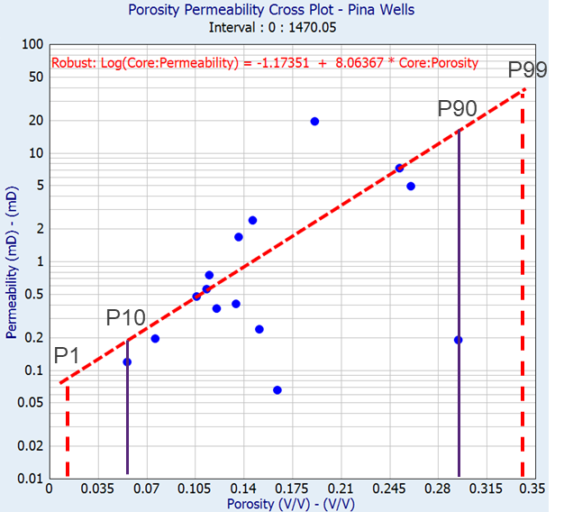

Figure 1: Porosity-Permeability Cross-plot for all available core data in Pina (26 plugs)

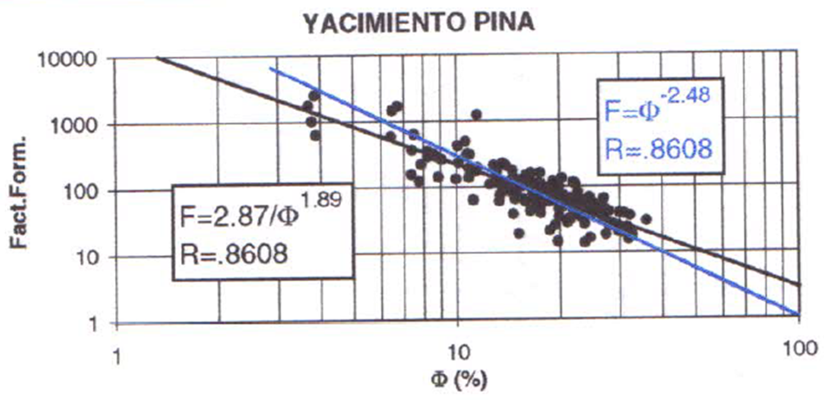

Figure 2: Formation Factor vs Porosity plot

Factor found is between 1.89 and 2.48 and ERCE has used a factor of 2.00.

A graph of residual phase saturation vs porosity from an analogue database (the database unfortunately does not differentiate between oil or gas residual phase) was plotted and compared against the Pina field. Also included is the residual phase saturation associated with core plugs measurements made in a “Chinese Tight Gas Sand” field in the Ordos Basin. ERCE observed that the residual phase in the Pina Field is low; the measurements seem to cluster close to measurements made by core lab in 2015, in highly clay-rich, shaly sands. A low residual likely means good sweep efficiency, with very little remaining oil in the pore space.

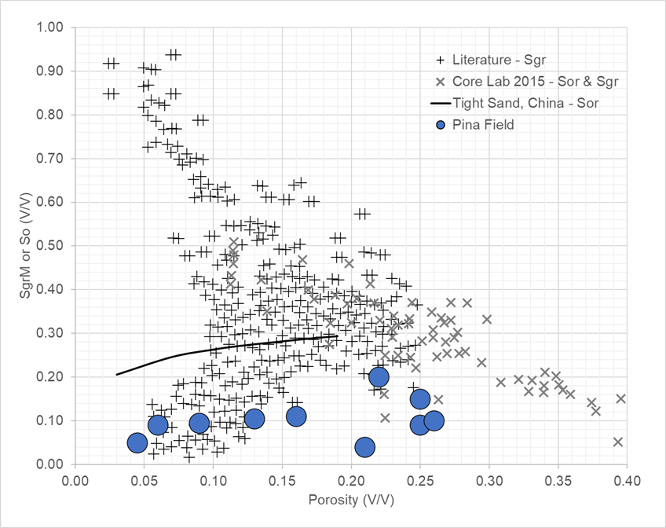

Figure 3: Residual phase saturation vs Porosity plot

There were 23 samples - 7 samples porous-plate (PP), 10 samples centrifuge (Cent - fluid type reverse engineered to be oil-water) and 6 samples mercury intrusion (MICP). All Pc samples used to constrain height above free water level (HAFWL); Pc is also useful to show the pore size distribution. It is observed that while most of the pore space is made up of macropores and micropores with mesopores acting to bridge the 2 pore sizes

* Macropores (≥ 1.5 mm) – Porosity between grains (intergranular), fracture width > 50 mm
* Mesoporosity (≥ 0.03 - 1.5 mm) – Porosity associated with silts or very fine grain, within particle itself, fractures width 5-50 mm
* Micropores (≤ 0.03 mm) – Porosity associated with clays or microfractures, fractures width < 5 mm

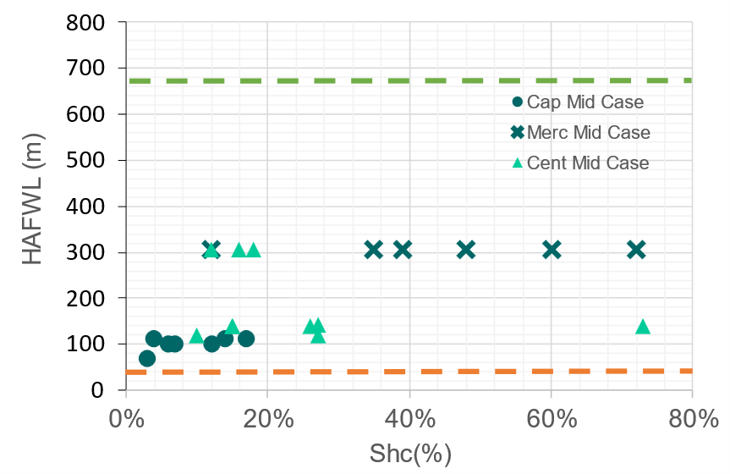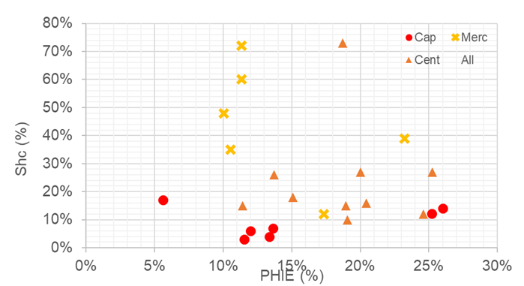

Figure 4:

It was found that samples using Mercury Intrusion Capillary Porosimetry method read higher saturations than by centrifugation and capillary, not fully saturated in the other methods. Low, mid, high determined by wide range of oil gradient, water gradient, shown in Table ??.

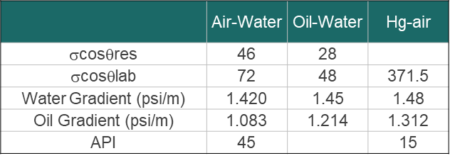

Table 1: Summary of gradients

Results for thin sections are shown below. Figure 5(a) shows that micropores are in connection while there are clay present in macropore. The pore appears isolated. Calcite-filled flow channel with some “epoxy” present within fracture can be seen in Figure 5(b).

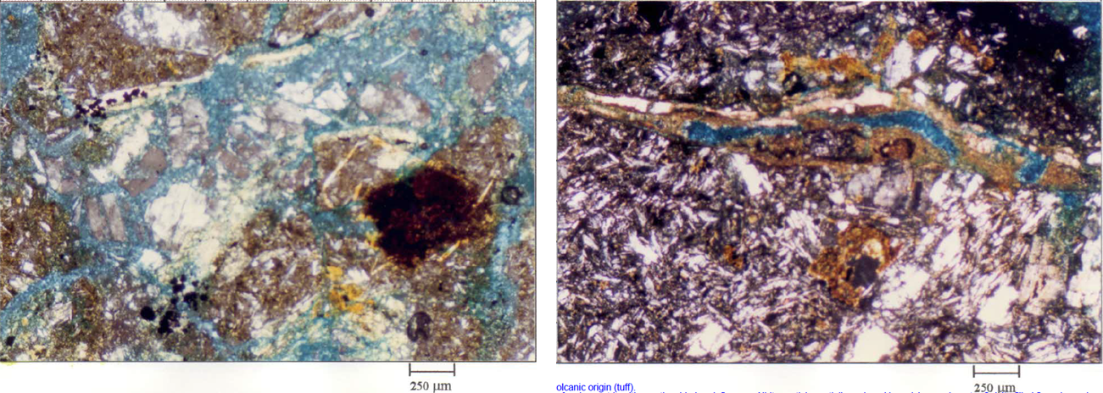

Figure 5(a):

Sample with characteristic needle fragments of volcanic origin (tuff). Tuff is complicated because it is hard to define/ separate macro/meso/micro due to surface roughness.

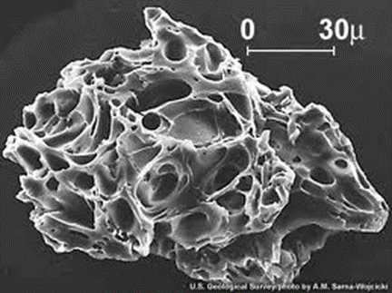

Figure 6: SEM image of a single particle from the eruption of Mt. St. Helens

When looking at top volcanics at 1048 mTVD in PI-154, samples 12 – 20 (980 – 1080 m) very broken on the thin sections, possibly very brittle. There are also fragments of albite, polycrystalline quartz and abundant detrital clay matrix.

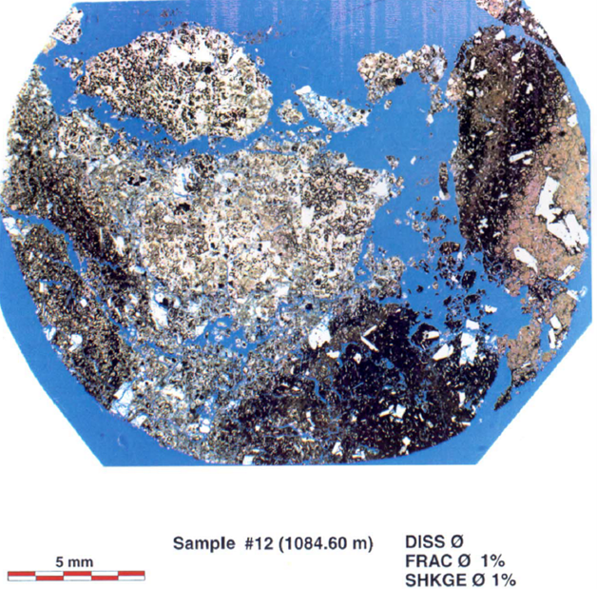

Figure 7: Sample #12 at 1084.6m

For top efusivos at 1048 mTVD in PI-154, there are fine grained plagioclase and carbonates.

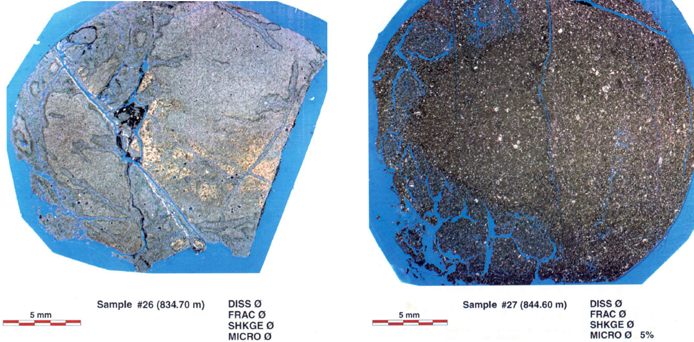

Figure 8:

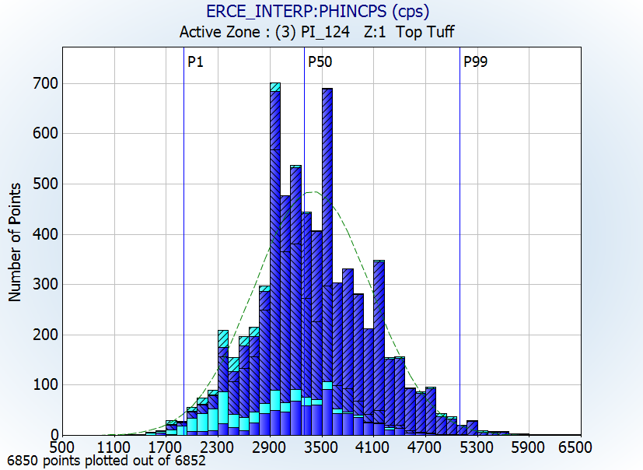

Figure 9:

The P1-P99 values of the PHIN histogram are calibrated to the P1-P99 core values. PHIN is scaled by multiplying with a constant of 10000 to increase the dynamic range of the data. PHIN - P1: 1800 & P99: 5100.

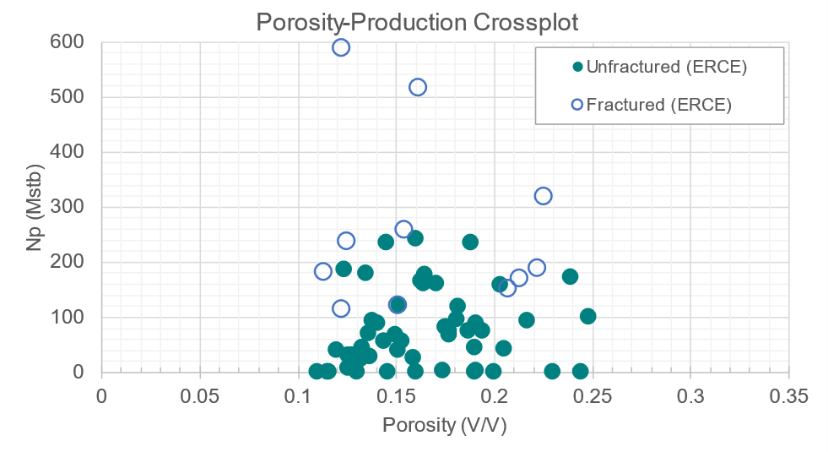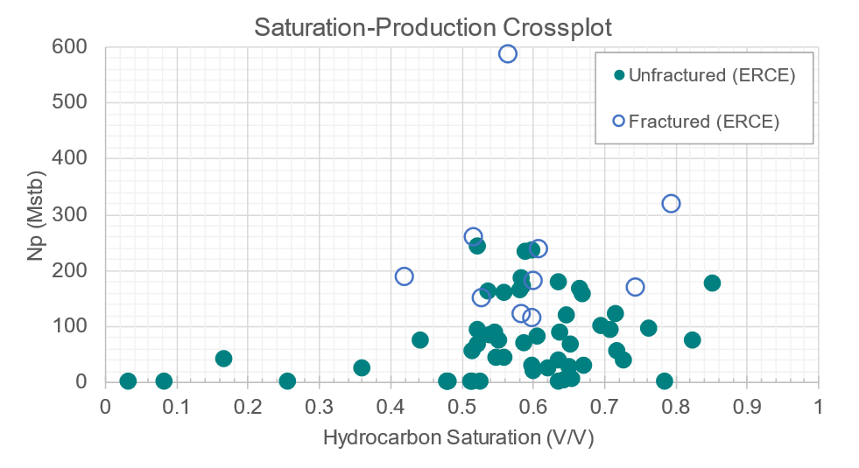

Unfractured wells do not show increase in performance with better porosity. Fractured wells perform better than unfractured wells. Lower porosity rocks seem to perform better after fracturing. Fractured wells perform better than unfractured wells, regardless of saturation. Saturations > 50% are zones that can contribute significantly to produced volumes.

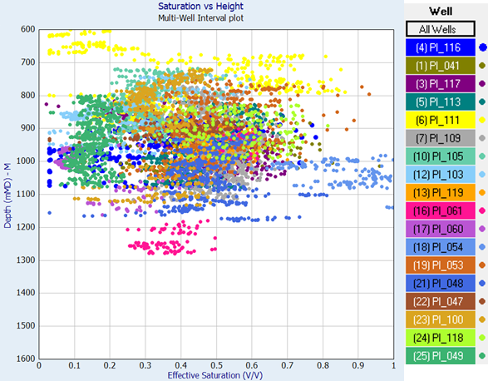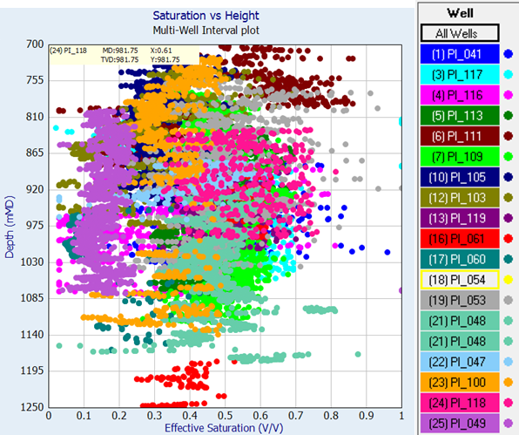

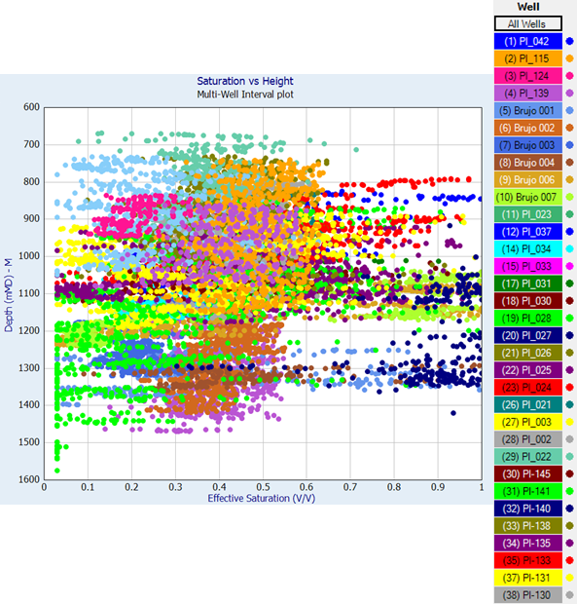

Consistent water saturation distribution at ~40% (P50). Low side and High side vary ±10-15%. Some variation with height; correlation is weak.

PHINCPS is normalised between 1000-6000.

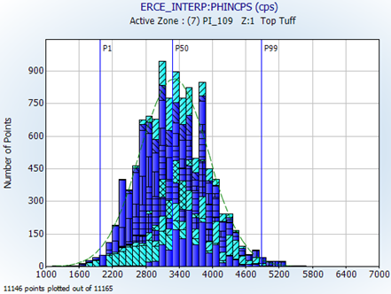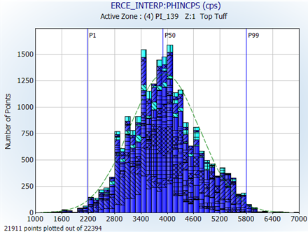

For NEAR, there is large range in the wells and PI_053 centered around 4.2 cps instead of 1.5 cps.

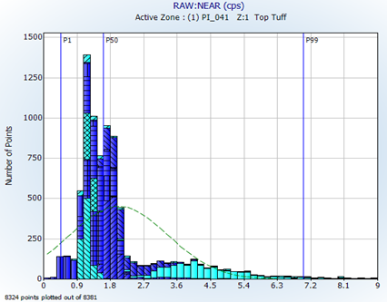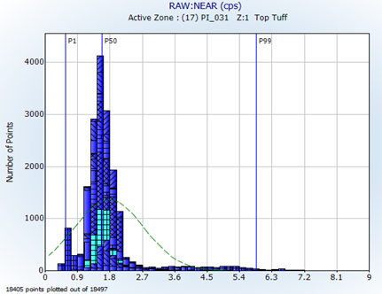

For FAR, there is large range in wells and PI-054, PI-048 and PI-047 centered around 1.2 cps instead of 3.6 cps for the P50 of the other wells.

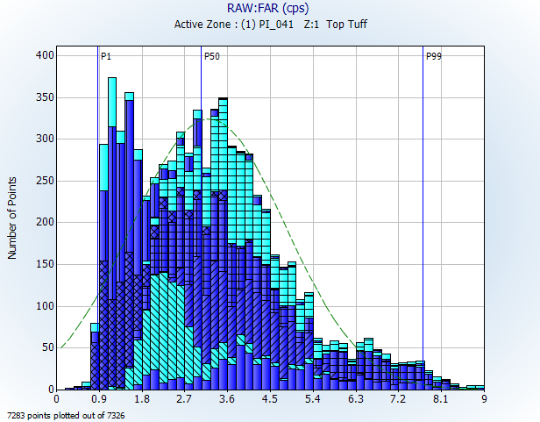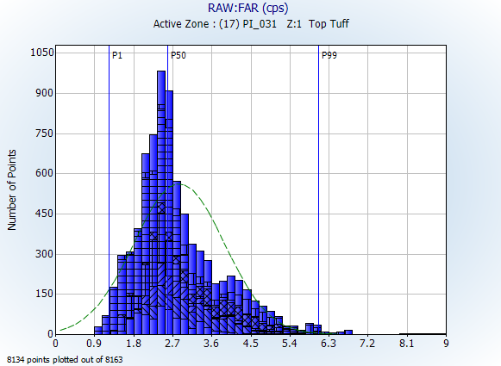

Discussion

Majority of the tuffs are quartz and feldspar (framework) with clay as the next major component. Average framework grains is 61.6%, average ductile components is 24.5% and Average Authigenic Components ~13.9%. This supports the assumption that fracking is affecting the ductile components; the cements are mostly within healed fractures. Hydrocarbon fluid would be contained in the macroporosity supported by the framework grains. Depending on column height, and given the extensive proportion of microporosity, hydrocarbon can potentially fill the micropore space as well.

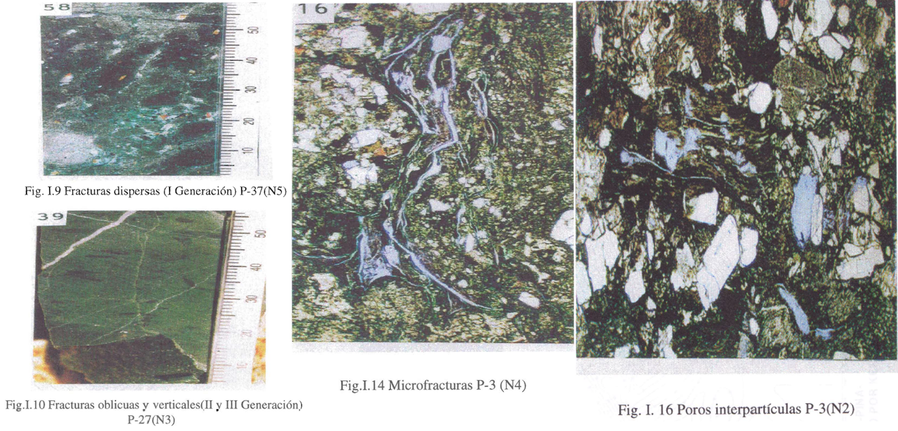

There is fracture anisotropy here and both filled and unfilled fractures are observable. In combination with capillary pressure data, fractures do not contribute to volumes but are extremely important for connectivity (most volume is held in interparticle, macroporosity and microporosity).

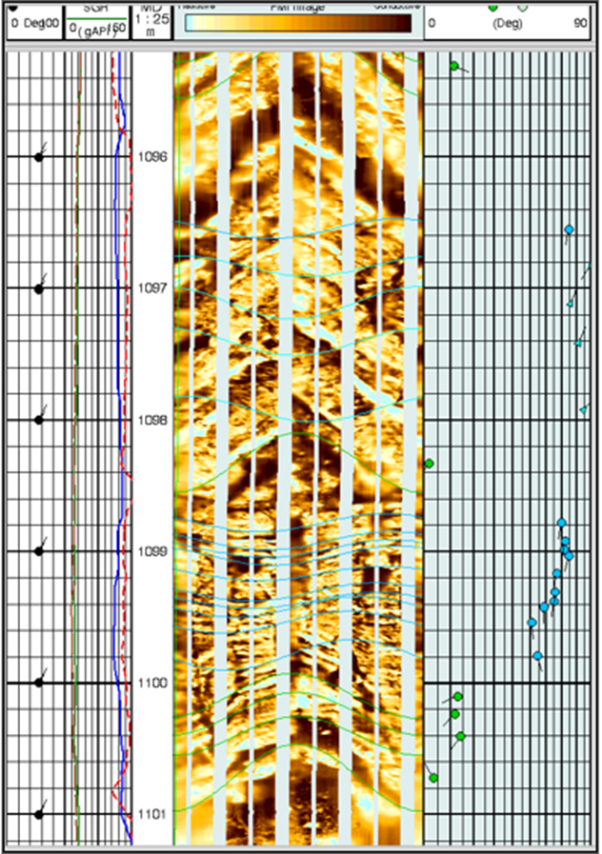

Induced fractures are fractures are filled with conductive drilling fluid. The formations above and below sinusoid are not very different which indicates no displacement of the rock, therefore it is not a fault instead it is a fracture.

No observable correlation between porosity and saturation distribution at a field-wide level; differences appear to be randomly distributed. After calibration, ERCE notes that ~50% of the wells of the wells with a material difference in porosity (± 4 p.u.) to client, with 16 wells being ± 8 p.u. or more than the client (~22%). ERCE porosities are generally lower (63 wells) but within core limited boundaries.

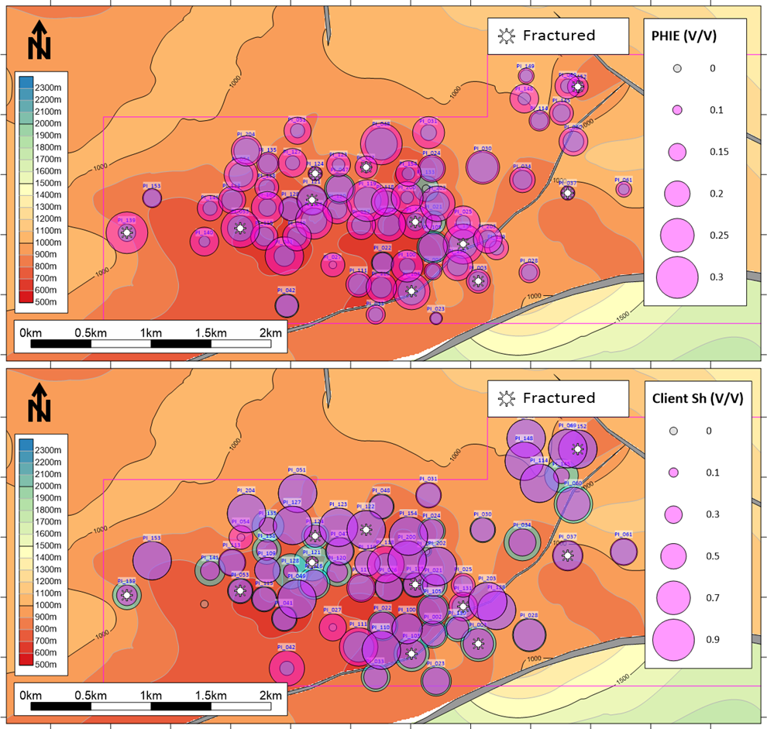

No observable correlation between porosity and production distribution at a field-wide level. The three largest producers have been fractured; original porosities at fractured wells varies between 10 – 25%. Porosity variation does not seem to impact frac efficacy. Well sorted systems with little to no clay are less ideal candidates for fracking.

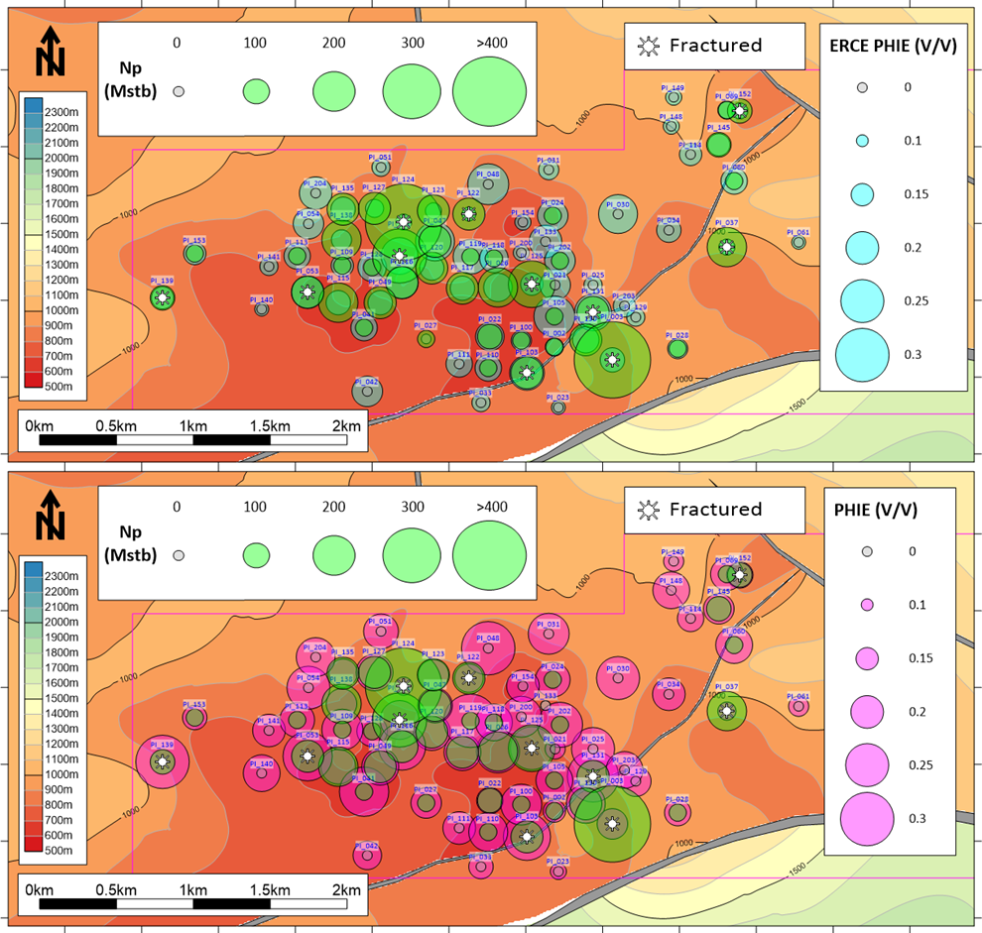

No observable correlation between saturation and production distribution at a field-wide level. The three largest producers have been fractured; original saturations at fractured wells varies between 50 – 90%.

Caveat: ERCE has noted that production is co-mingled with some contribution from effusives and volcanics in certain wells. Based on the available data set, ERCE is unable to break out the production contribution from the non-Tuff intervals. The plot of perforation length vs Production assumes that only the Tuff are contributing. Based on the plot, there is no correlation between cumulative production and perforation length

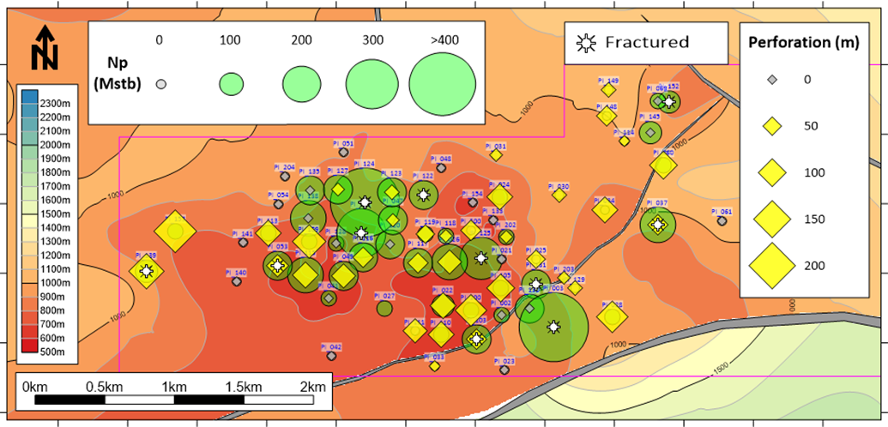

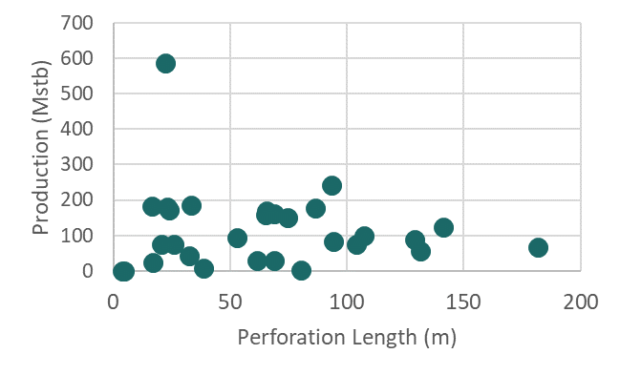

Conclusion

Conclusion